Question 35 (14 marks)

Many retired soldiers have made the trip to Papua New Guinea to walk the Kokoda Track in memory of the Kokoda Trail campaign fought during World War II. The track is made difficult because of the extreme humidity and heat, but if people look after themselves properly during the trek, the track is manageable.

1. Describe two problems that the extreme heat and humidity could cause for the retired soldiers walking the track. (2 marks)

Heat – heat exhaustion/too hot enzymes denature and effect all body functions/chemical reactions in body are heat sensitive/can cause nerve damage/change in structure of proteins/death. (1)

Humidity – heat stroke/sweating has little effect so difficulty cooling the body (1)

1. The control of the body’s internal environment is essential if the person is going to be able to function properly and respond to the demands of such an arduous task of walking the track.

Complete the feedback loop shown below to show how heat loss can be physiologically increased from the body to prevent overheating. Do not include the behavioural response.

(5 marks)

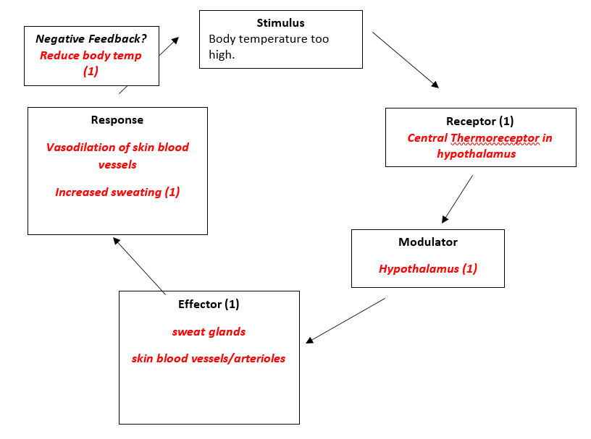

c)

Humidity does not allow for evaporation of sweat from skin

(1 mark)

1. The feedback loop is an effective mechanism for maintaining the body’s core temperature. However the process of sweating initiated by the effector can cause other problems for the body.
   1. (1 mark)

Loss of water through sweating